**"Real Estate Data Management System"**

**Business Process:** Designing and Implementing the Database management system in place of the existing system that incorporates Excel spreadsheets, for a well-defined process of purchasing an apartment in Real Estate business.

**Background**: Due to a spike in IT parks over the region of Tampa, more IT professionals are moving in that area and looking for permanent accommodation there. This has led to a boom in the real estate business in Tampa. The real picture of such a scenario is not as simple as it seems. This is because this essentially leads to a transition from dealing with a lower volume of data to tackling with a sudden data deluge triggering a shift from using the traditional Excel to using a well-managed sophisticated Database System. A huge amount of data that would be generated about the Customers, Real Estate agents, Management Team, the property that is sold and maintained and the transactions initiated for the same are to be taken into consideration. The business process that we are modelling ranges from selling of properties to maintaining them as a well-organized structure of tasks. Earlier with a smaller population a certain Excel sheet was considered enough to manage all the details of customers, buildings and apartments. Now, it would be preposterous to assume that given this large influx, the same can be managed by mere spreadsheets. Project owners and managers came forward with the idea of automating the process via a front-end JEE application having a Relational Database at the back end and corresponding Relationship Database Management Systems to streamline and store data coherently.

**Why BUSINESS PROCESS?** The activities which were performed as part of the AS-IS process lacks coherency. Every process was dependent on completion of every other process and could not be done independently. For e.g. as in the AS-IS Process after a customer decides to buy an apartment it could take weeks for the background verification process (document, credit history verification) to be completed. This is because mangers would forward the data to respective evaluation agencies manually who in turn would take their own time to help managers come to the conclusion(Yes/No).This delay in turn leads to frustration and exasperation from the customers’ end and if the decision is a Yes, then other subsequent activities are also delayed which could potentially lead to losing of customers. Hence the best option would be having an automated application where users fill the data and this data can be accessed real time from the database from other third-party evaluators and they can then provide a decision within splits of seconds which would help brokers and managers to take a call. For the customers who have been found not eligible, those records would be deleted by the broker/manager by a single click from the front end of the application which would delete the record from the master database. As is already showcased in our Swim Lane Diagram the triggering event would be an online enquiry from the customer through a phone call/email from the real -estate business portal. The results achieved would be finalizing and booking the apartment and making down/full payments for eligible customers within minutes through a smart device only through an application primarily as opposed to manual tedious processes and activities of maintaining excel spreadsheets and cascading the data to respective departments for further actions. Also, customers themselves can access the application to make EMI payments and update any missing details which was part of the original application. Of course, there would be access restrictions and limited views of the application that would appear to customers. This will unequivocally alleviate the pain of both managers and customers in terms of the whole process.

**TO BE Process and Benefits over AS IS:**

There are various advantages that the system would have in switching from maintaining manual Excel to an automated process. A few of them with reference to the backend part of the application(database)are as follows:

* dealing with the problem of data redundancy. For example, let us suppose there is an excel sheet consisting of customer details, the apartment that they have booked and the complaints that they might face in their apartment or building. So, to make the data easy to understand, the details of the customers (first name, last name, contact, email etc.) will be repeated a number of times in the record that describes their purchase and then in the record that describes their complaints. This data is redundant and occupies a lot of space in the sheet. When we switch to database, we can simply create 2 different tables, 1 consisting of customer details and the other consisting of complaints and draw relations between them.
* Excel applications are approachable and flexible. But with more flexibility comes greater risk. This can lead to more work, more waiting and more versioning and lower accuracy. While with SQL, the process can be faster and safer.
* SQL incorporates the feature of referential integrity which is a great advantage over Excel. With referential integrity comes more database consistency. It ensures that the relationships between tables in a database remain accurate by applying constraints to prevent users or applications from pointing to inaccurate data or to the data that doesn't exist .In business parlance, a minor unauthorized tweaking of data can wreak havoc in terms of veracity of claims of the real estate company which was the main risk of the AS-IS process.
* The above disadvantages of using excel with a huge amount of data go hand in hand with the ease of making accidental changes to the data, difficulty to replicate old analysis to the new data, problem of sharing big sheets over email etc. These all run the risk of damaging the spreadsheet with significant dent to the ambitions of growth of the real estate company.

Our task as Management Team would be to consider all the aspects of data and entities from every stakeholder involved here and come up with a robust Database which would be indispensable in case of data management.

The AS IS process of the system deals with the records updated from time to time in an Excel sheet as an activity gets completed, which are prone to a lot of accidental alterations, incorrect data input and the evergreen problem of data redundancy. We are shifting this process into a well-defined relational database management system which is the TO BE state of the process and is described as follows:

1. Customer fills his/her name, contact details and the type of apartment he/she is interested in, on an online portal (can be business portal of the Real Estate company).
2. The Real Estate Agents contact him/her for the possible options available in compliance with the customer requirements.
3. The Real Estate Agent schedules an appointment with the customer to decide on a location.
4. The Manager ensures that the subjected apartments are in good condition before the customer pays a visit.
5. The customer visits the apartments of his interest with the Real Estate Agents.
6. The customer negotiates with the Agent on the price of the apartment depending upon his requirements of the apartment that have been fulfilled and that have not been fulfilled by the Agent.
7. The Manager decides whether to approve the apartment to the customer or not depending upon the price negotiated between the customer and the Agent. If the Manager rejects the negotiated price, then the process goes back to the previous step of negotiating the price, else the Verification Agent verifies the financial profile of the customer.
8. If the financial profile of the customers is successfully verified, down-payment is initiated by the manager along with the submission of identity, financial and insurance documents by the customer, else, the process goes to end.
9. After submitting the documents, the manager draws the contract and the customer signs it.
10. The records are updated in the database by the Manager and the process ends.

**ACTORS:**

1. Customers
2. Real Estate Agents
3. Management
4. Verification Agent
5. Computer System

**SWIMLANE of the TO BE and AS-IS Process (Please note that basic activities of both the scenarios are same the difference being now the entire application process is automated being filled up via a front-end application and we as Database Managers would keep a track of activities in the tables):**

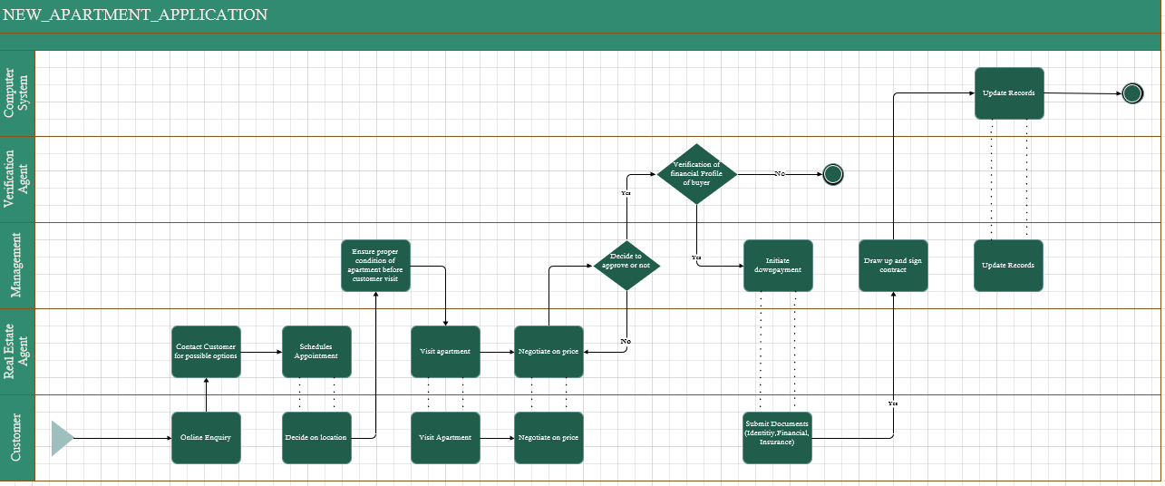

**ENTITIES:**

1. **Customers:** The entity consists of the customer details which are recorded in the following attributes.

* Customer_Id **(PK)**: Stores the customer ID which is unique for each customer.
* Broker_Id **(FK)**: Stores the broker ID which is unique for each broker.
* Apartment_Id **(FK)**: Stores the apartment ID which is unique for every apartment.
* First_Name: Stores First Name of the Customer.
* Last_Name: Stores Last Name of the Customer.
* DOB: Stores the Date of Birth of the Customer.
* Marital_Status: Stores the marital status of the customer.
* Salary: Stores the salary of the customer.
* Family Members: Stores the number of members who would live together in the apartment.
* Phone: Stores the phone number of the customer.
* Email: Stores the email ID of the customer
* Balance_Due: Stores the total balance that is due for the customer.

1. **Apartments:** This entity stores the details of the apartments under Apartment_Id, Building_Id, Sold (Contains the status of the apartment, Y: sold, N: Not Sold) and Apartment_Type.
2. **Staff:** This entity stores the details of the staff which are listed under Staff_Id which is unique for every building, Building_Id and Manager_Id which act as the foreign key, First_Name, Last_Name, Contact, Designation of the staff.
3. **Brokers:** The details of the brokers involved in the process will be entered under Broker_Id, which is unique for every broker, First_Name, Last_Name, Contact and Email of the broker.
4. **Complaints:** If at all, any customer has any complaints from any apartment of any building, then it has been planned to be recorded under Complaint_Id, Customer_Id, Building_Id, Description.
5. **Transactions:** The transaction details of each transactions are captured under attributes of Transaction_Id, Customer_Id, DoT (date of transaction) and Amount storing the amount that has been paid in that particular transaction.
6. **Buildings:** The description of every building covered in this process has been recorded in attributes Building_Id and Building_Name.
7. **Amenities:** The amenities of the building will be clearly defined by the attributes Amenity_Id, Amenity_Name and Monthly_charges that the customer needs to pay for using each amenity.
8. **Building_Amenities:** As per the requirement of the process, this is an associative entity between Buildings and Amenities.

**Assumptions:**

1. We are assuming that our database would be accessible to third party applications from which they will pull data of customers to do a quick evaluation. Also as mentioned previously, there would be payment gateways enabled for the application through which customers can make the payment for EMIs. After the payment is made, the same should be populated in our Transactions table and accordingly into the front end of the application. Please note that we have a Customer table which has column “Balance_due” which is dependent on Transaction tables. PLSQL procedures/triggers enable automation that every time a payment is being made and a new record enters the Transaction table, there will be a decrease in “Balance” column through DML statements. Also, ACID properties are enabled in transactions which means if there is a transaction failure then the changes in both the tables will be rolled back. The price of the apartment which both parties agrees on is maintained separately in legal documents and the same can be compared against the total payment made as of date by the customer.

**Information that can be extracted from the Database that can be presented as reports to the Higher Management, based on which they can take business and other decisions:**

1.Owners of the real estate business might want to look at hierarchy of staff. This comes in handy when they are considering a raise for any particular staff and enquiring who this staff reports to.

2.Commission percentage according to the number of customers who bought apartments that each broker brings.

3. What are all the common complaints that are being received from residents of a particular building?

4.What is the total amount being paid by a customer till date?

5.Find out last payments being made by all or a specific customer.